PHASE 6: USER INTERFACE DEVELOPMENT
1. Lightning App Created
- App Name: Salesforce Ticket Tracker
- Included the custom tab for Salesforce Ticket object.
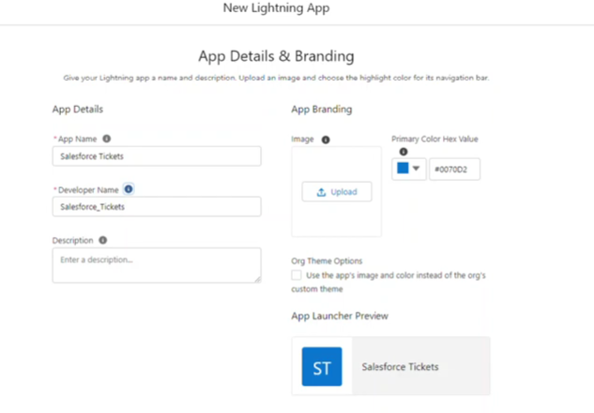

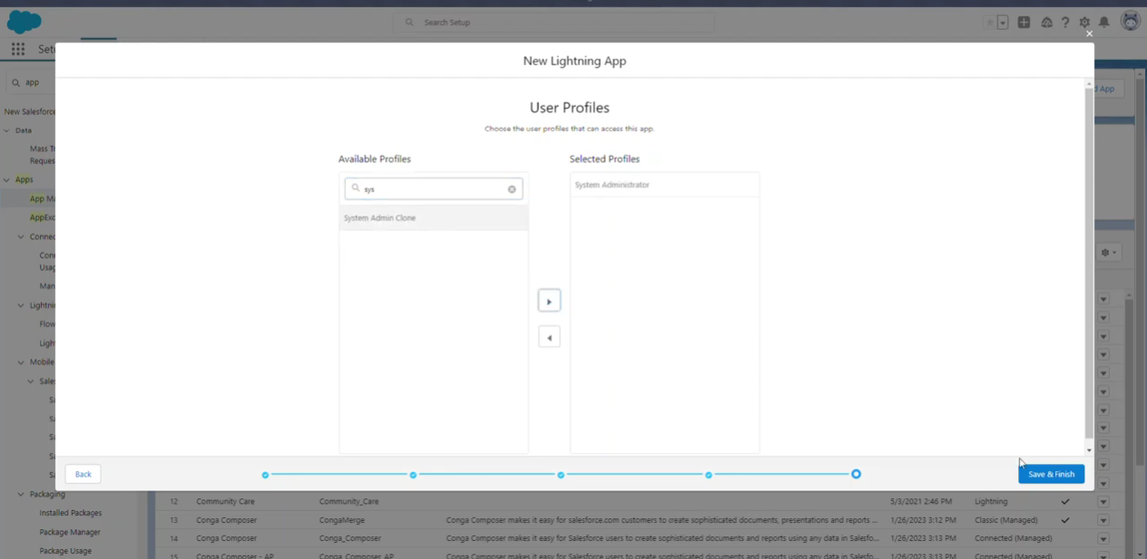

2. Custom Tab Created
- Created a new tab for Salesforce Ticket object
- Assigned visibility to System Administrator

3. Record Page Enhancements
You modified:
- Highlights Panel
- Field positioning
- Added Notes & Attachments

